Curriculum Vitae (as of January 2010) 附件一

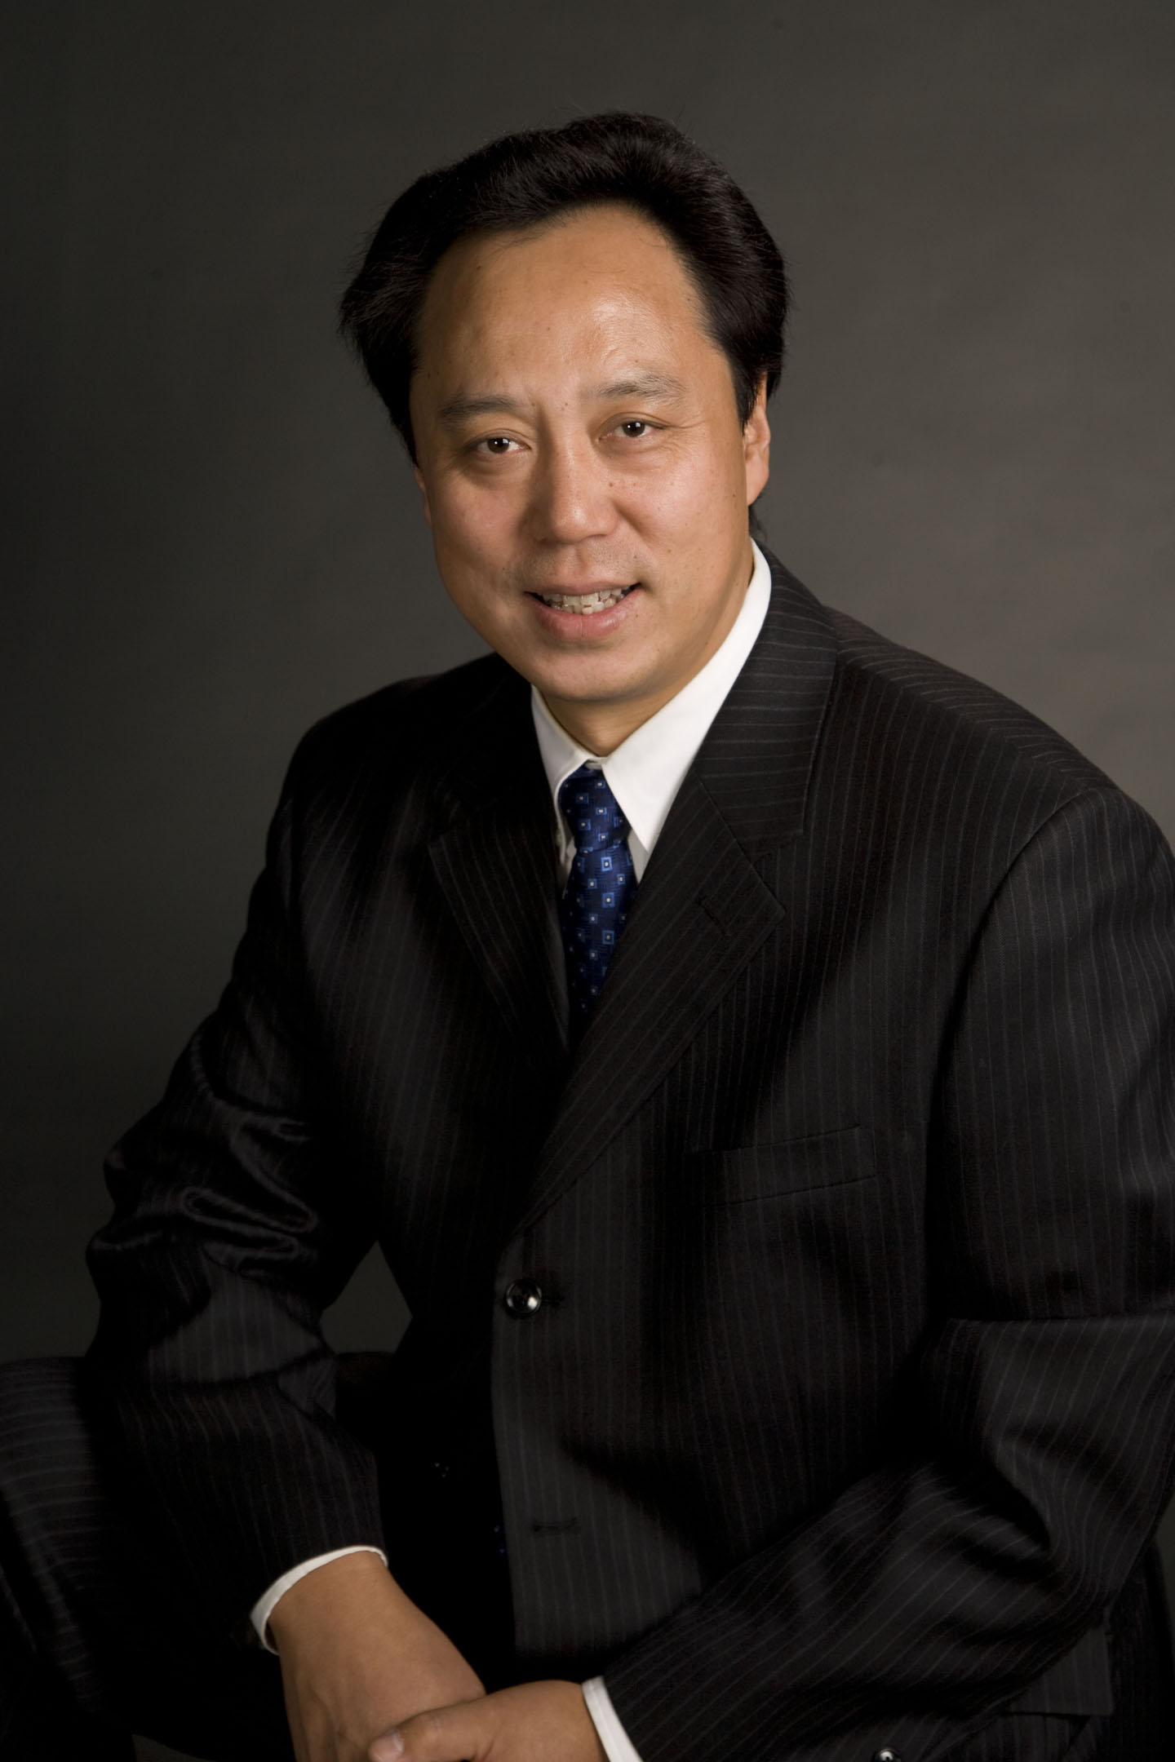
Name: Wei Yan M.D., Ph.D.
Work Address: Department of Physiology and Cell Biology
University of Nevada School of Medicine
Anderson Building, Room 111
1664 North Virginia Street, MS352
Reno, NV 89557
Phone: +1 775 784 7765 (Office)
+1 775 852 0798 (Home)
+1 775 338 9885 (Cell)
Fax: +1 775 784 6903
E-mail: wyan@medicine.nevada.edu
Date of Birth: August 12, 1968
Gender: Male

EDUCATION
Post-Doc, 2000-2003, Baylor College of Medicine, Houston, TX
Mentor: Martin M. Matzuk, M.D., Ph.D.

Ph.D., 2000, University of Turku, Turku, Finland
Thesis: Expression, Regulation, and Function of Stem Cell Factor in the Rat Testis
Mentor: Jorma Toppari, M.D., Ph.D.

M.D., 1990, China Medical University, Shenyang, China

Professional Appoinment
Associate Professor (2009-present, tenured): Department of Physiology and Cell Biology, University of Nevada School of Medicine, Reno, NV

Laboratory Director (2004-present): Northern Nevada Fertility Clinics, Renown Medical Center, Reno, NV

Assistant Professor (2004-2008, tenure-track): Department of Physiology and Cell Biology, University of Nevada School of Medicine, Reno, NV

Instructor (2003-2004): Department of Pathology, Baylor College of Medicine, Houston, TX.

Sept. 1985--Jul. 1990: Medical Student, China Medical University, Shenyang, China; Awarded M.D. degree in July 1990.

Academic membership
Sigma Xi
The Endocrine Society
The American Society of Andrology
The Society for the Study of Reproduction

Awards/Honors
2009 The Nevada High Education System Regents’ Rising Researcher Award.
2009 Society for the Study of Reproduction Young Investigator Award.

2003 Finalist of the American Society of Andrology Trainee Award, Phoenix, Arizona.
2002 Ernst Schering Research Foundation Young Scientist Fellowship.
2000 Finalist of the NAFA Young Scientist Award 2000, Malmö, Sweden.

1999 The Best Poster and Presentation Award, the 25th Annual Meeting of Finnish Endocrine Society, April 23-24, 1999, Helsinki, Finland.

1997 Scholarship from Turku University Foundation, May 28, 1997, Turku, Finland.

TEACHING INTERESTS AND EXPEREIENCE
Basic medical courses for the 1st year medical students including Anatomy, Embryology, Histology, System Physiology and Molecular and Cell Biology.

2004-Present:
System Physiology (PCB611): 1st year medical students
Clinical Embryology (PCB604): 1st year medical students
Practical Histology (PCB602): 1st year medical students
Cellular and Molecular Biology: CMB graduate students

2004-2005:
Developmental Biology (BIOL191): 3rd year undergraduate students

2004:
Bioinformatics (CMPP793): CMB graduate students
Molecular Biology: CMB graduate students

RESEARCH INTERESTS
Molecular and cellular biology and physiology of reproduction. Current specific interests: (1) the regulation of protein turnover by ubiquitination during spermiogenesis; (2) the control of cytoplasm removal during sperm individualization and spermiation (sperm release); (3) physiological roles of germ cell-specific small non-coding RNAs.

GRANTS AND FELLOWSHIPS

Current:
“Regulation of Spermiogenesis by KLHL10”
PI: Wei Yan, NICHD, RO1-HD050281, 2006-2011
Major Goal: Study the molecular mechanisms by which KLHL10 regulate spermiogenesis.

“Regulation of Spermatogenesis by X-linked miRNAs”
PI: Wei Yan, NICHD, RO1 HD060858, 2010-2015
Major Goal: Mechanism of miRNA-mediated meiotic sex chromosome inactivation in mice.

“Smooth muscle plasticity: COBRE”
PI: Kenton Sanders, NIH/NCRR, P20-RR18751, 2009-2014
I serve as the Director of the Molecular Expression and Transgenic Core (Core B) and a mentor of Project 4.
Major Goal: Investigate the role of plasticity in smooth muscle.

Professional committees and activities

JOURNAL EDITORIAL BOARD
July 2009-June 2013 Member Molecular and Cellular Endocrinology
July 2009- Member Biology of Reproduction

University level:
2007-Present: Member of the Institutional Animal Care and Use Committee
2008: Member of the Lab Animal Medicine Review Committee for the Provost and VPR

PhD thesis committee
2009-present Tong Chang, CMB
2008-Present Daniel Oliver, CMB
2008-Present Peter J. Blair, CMPP
2007-present Conor McCann, CMPP
2006-2010 Andrew R. Kuhn, CMPP, graduated in 2010
2004-2007 Hui Chen, CMPP, graduated in 2007

Research Assistant Professor
2007-present Huili Zheng, MD, PhD
2005-present Seungil Ro, PhD

Post-Doctoral Fellows
2009-present Yonghai Li, PhD
2008-2009 Zeili Lei, PhD
2005-2009 Chanjae Park, PhD
2005-2007 Jingling Jin, PhD, currently at Baylor College of Medicine
2005-2007 Can Yuan, MD, PhD, currently in University of Washington, Seattle.

Graduate Students
2008-2010: Jianqiang Bao Visiting PhD student
2008: Benjamin F. Stump Medical Student
2007-Present: “Susan” Qiuxia Wu B. Sc.
2007: Jason Michaels Medical Student
2007: Anita Batra Medical Student
2006-Present: “Steven” Rui Song B.Sc.
2006: Myra Godfrey B. Sc.
2005-Presnt: Shouhua Wang Ph.D.
2004-2005: Alan O’Doherty B.Sc.

Undergraduate Students
2010-present Jami Bahney
2009-Present Charles Jose
2007-2008: Yvette Hollett
2007-2008: Scott Cunningham
2007-2008: Danny Villalobos
2006-2007: Dora Tafolla
2006-2007: David Young
2005-2007: Jonathan Cho
2005-2006: Dan Nguyen
2004-2005: Yumiko Esaki
2004-2005: Joo Yean Baek
2004-2005: Fiona Kelly
2004-2005: Ann De Salvo

